

**THE DUKE OF EDINBURGH’S**

**INTERNATIONAL AWARD**

**BRONZE QUALIFYING**

**ADVENTUROUS JOURNEY (AJ)**

**REPORT**

*Name:__________________________*

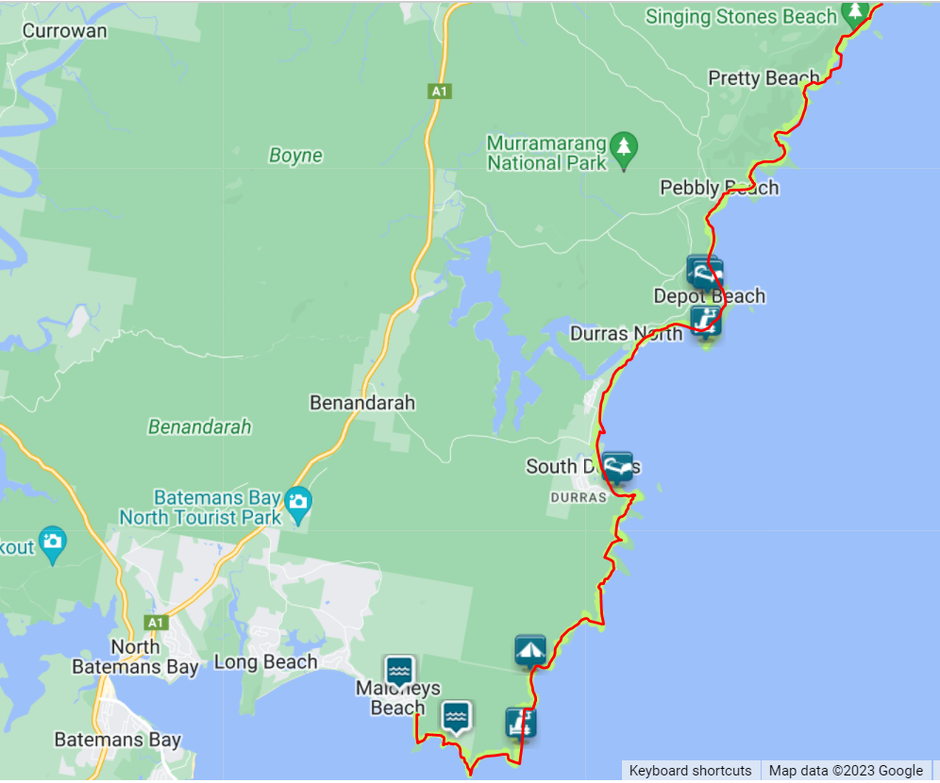

|  |  |  |
| --- | --- | --- |
| **Journey Name** | Murramarang South Coast Walk | |
| **Journey Type** | Expedition | |
| **Mode(s) of Travel** | Bushwalking | |
| **Dates** | **Start 8 / 9 /2023** | **Finish 11 / 9 / 2023** |
| **Location Details** | Between Batemans Bay and Ulladulla, south coast of New South Wales | |
| **Journey Goal / Purpose** | To develop teamwork skills while negotiating a challenging outdoor environment | |
| **Supervising Organisation** | Orana Steiner School | |
| **Assessor** | Nick Crisp ([Nick.Crisp@oranaschool.com](mailto:Nick.Crisp@oranaschool.com)) | |

**Journey Group Members**

|  |
| --- |
| **Supervisor(s) – Nick Crisp** |
| **List your group here. Groups must be from 4 -7 members.**  Enter your group names here |

**Pre-Journey Information**

|  |  |  |  |  |  |  |  |  |  |  |  |  |  |  |  |  |  |  |  |  |
| --- | --- | --- | --- | --- | --- | --- | --- | --- | --- | --- | --- | --- | --- | --- | --- | --- | --- | --- | --- | --- |
| * Murramarang National Park is situated on the coast just north of Batemans Bay and south of the Kioloa State Forest in NSW. The park includes beaches, wetlands, waterways and rainforests. Birdlife includes parrots, lorrikeets and rosellas and seabirds such as pelicans and sea eagles. Marsupials living here include possums, bandicoots, kangaroos and wallabies. * *Outline the skills you acquired during your Preparation and Training and your Practice Journey* * *Outline the physical fitness preparation for the Qualifying Journey* * *Weather / environmental / timing notes prior to departure (see table below)*  |  |  |  |  |  | | --- | --- | --- | --- | --- | |  | **Expected weather conditions** | **Expected terrain/environmental conditions** | **Distance**  **(km)** | **Expected time (hrs/mins*)** | | **Day 1** |  |  | **8km** | **3 hrs** | | **Day 2** |  |  | **18km** | **8 hrs** | | **Day 3** |  |  | **10km** | **4 hrs** | |

**Map/Route Plan**

|  |
| --- |
| ***Insert images/photos of the map used showing:***   * *Map Name* * *Route (including start and finish points) and route summary (eg total distances/times)* * *Meal stops, check/rendezvous/meeting points, water sites and campsites* * *The groups progress during the journey* * *Environmental features and points of interest* |

**Equipment List**

|  |  |
| --- | --- |
| **Full equipment list:**   * **Hiking bag** * **Sleeping bag** * **Sleeping mat** * **Clothes** * **Coking equipment** * **Food** * **Gas stove** * **Torch** * **Dry bag** * **Toiletries** * **4.5L water** | **Equipment review:**  *eg comments on equipment taken which was essential, useful, inappropriate or unnecessary, and equipment not taken but which would have been helpful*  All of the |

**Clothing List**

|  |  |
| --- | --- |
| **Full clothing list:**   * **T-shirt 2x** * **Sleeping pants** * **Hiking pants** * **Hiking shoes** * **Thermals** * **Jacket** * **Fleece** * **Underpants 3x** * **Socks 4x** * **Slides** * **Hat** | **Clothing review:**  *eg too much / too little, essential, useful, inappropriate or unnecessary, clothing performance issues (eg waterproofs, shoes, thermals etc…). What other clothing would have been desirable?* |

**Food List/Menu Plan**

|  |  |
| --- | --- |
| **Full food list:** (eg daily rations, include emergency food)   * **3x mars bar** * **6x Nutrigrain bars** * **Trail mix** * **Mac n cheese microwave meal 2x** * **Porridge 6x** * **Wrap bread** * **Tuna pouch** * **Cream cheese** * **Jelly snakes**   **Cooking equipment/utensils list:** (eg daily rations, include emergency food) | **Food review:**  *eg comments on adequacy of rations, ease of preparation, waste/rubbish produced. Was emergency food required? What tasted good and what didn’t you feel like eating, why?*  *Was your water supply adequate? Were there any water supply issues?* |

*If possible also include a Menu Plan. Such a Menu Plan could be set out as below, or you can insert an image/photo of the Plan you may have used for your Journey.*

|  |  |  |  |
| --- | --- | --- | --- |
| **Meal** | **Day 1** | **Day 2** | **Day 3** |
| **Breakfast** |  |  |  |
| **Lunch** |  |  |  |
| **Dinner** |  |  |  |
| **Snacks** |  |  |  |
| **Emergency Food** |  | | |
| **Other** |  |  |  |

**Description of Journey**

Note – a minimum ½ page description is expected for each day but Day 1 can be shorter.

**Day 1**

|  |
| --- |
| ***Suggested inclusions:***   * *Observations such as geography, weather, flora, fauna, etc…* * *Information – historical, geographical, scenic, etc…* * *Your highlights for the day* * *Items noted on the trip but not included on the map (new tracks etc…)* * *Any problems encountered/overcome* * *Adequacy of campsites, water supply, etc…* * *Photos / sketches etc…* |

**Day 2**

|  |
| --- |
| ***Suggested inclusions:***   * *Observations such as geography, weather, flora, fauna, etc…* * *Information – historical, geographical, scenic, etc…* * *Your highlights for the day* * *Items noted on the trip but not included on the map (new tracks etc…)* * *Any problems encountered/overcome* * *Adequacy of campsites, water supply, etc…* * *Photos / sketches etc…* |

**Day 3**

|  |
| --- |
| ***Suggested inclusions:***   * *Observations such as geography, weather, flora, fauna, etc…* * *Information – historical, geographical, scenic, etc…* * *Your highlights for the day* * *Items noted on the trip but not included on the map (new tracks etc…)* * *Any problems encountered/overcome* * *Adequacy of campsites, water supply, etc…* * *Photos / sketches etc…* |

**Supporting Evidence**

|  |
| --- |
| ***Evidence may include:*** *(scans/photos are acceptable)*   * *Leaflets* * *Clippings* * *Entry permits* * *Sketches* * *Photos* * *Etc…* |

**Thoughts/Reflections**

|  |
| --- |
| ***A Bronze Qualifying Journey is a memorable experience and a major achievement. Please record some of your thoughts and reflections of the trip below.***  ***Some questions to help you:***   * *Feelings about the trip – such as what you and the group learnt about yourselves and what* *were the highs and lows of the trip? What didn’t you like or enjoy?* * *What were the most memorable events/things you encountered on your journey?* * *How did your group work together? What were the benefits and problems?* * *What did you learn?* * *What were your proudest achievements during the journey?* * *What was most challenging about this journey?* * *What did you appreciate about the experience?* * *What would you do differently next time?* * *What advice would you give to someone before they went on a similar journey?* * *Any other matter relating to the trip and its organisation?* |